AMERICAN UNIVERSITY OF SCIENCE & TECHNOLOGY

FACULTY OF ENGINEERING

DEPARTMENT OF INFORMATION AND COMMUNICATIONS TECHNOLOGY



ICT 355L – INTERNET OF THINGS AND SECURITY LAB

ATTENDANCE SYSTEM

By

CHARBEL BACHAALANY

Submitted to

MR AHMAD DEEB

Achrafieh, Lebanon

June, 2023

**Abstract**

This project presents an IoT-based attendance tracking system that utilizes a Raspberry Pi 4 as the central board, an RFID tag/card integrated with an RFID sensor, and a blue LED. The objective is to automate attendance tracking by capturing an individual's presence when they tag the RFID card onto the sensor. Upon successful detection, a Model 5 camera connected to the Raspberry Pi captures a picture of the user's face. An email notification is then sent to confirm their attendance at their workplace, school, or any other designated location. The system further stores attendance information in a CSV file, creating one if it is not available.

The core components of the project include the Raspberry Pi 4, an RFID tag/card, an RFID sensor, a Model 1 camera, and a blue LED. The Raspberry Pi 4 serves as the central processing unit, facilitating seamless integration and communication among the components. When an individual tags their RFID card onto the sensor, the system detects their presence, triggering the attendance verification process.

Once the RFID tag/card is detected, the Model 1 camera captures a facial image of the individual. This image serves as visual evidence of their attendance. The system then generates an email notification, confirming their presence at the designated location. Additionally, the attendance information is stored in a CSV file, which is created if it is not already available. This allows for easy tracking and analysis of attendance records over time.

By automating the attendance tracking process, this IoT-based system offers several advantages. It eliminates manual recording, reducing errors and saving time for both individuals and administrative staff. The system ensures accurate attendance records, promoting accountability and enabling analysis of attendance patterns. The integration of email notifications and CSV storage enhances efficiency and convenience.

In conclusion, this IoT project utilizes a Raspberry Pi 4, RFID technology, a Model 1 camera, and email notifications to create an automated attendance tracking system. The system captures an individual's presence by detecting their RFID tag, takes a facial image as proof, and sends an email confirmation. Additionally, attendance records are stored in a CSV file for easy management and analysis. This project presents an efficient and reliable solution applicable to various environments where accurate attendance tracking is essential.

**Table of Contents**

**Abstract i**

**Table of Contents ii**

**I. Introduction 1**

**II. Objectives 2**

**III. Background 3**

**IV. Design and Procedure 4**

1. System Design 4
2. Step – by – Step Procedure 5
3. *Step 1 5*
4. *Step 2 5*
5. *Step 3 6*
6. *Step 4 7*
7. *Step 5 8*

**V. Problems Faced and Solutions 9**

**VI. Results and Conclusions 9**

1. Results 9
2. Conclusions 9

**Table of Figures**

Figure 1 – Model 4

Figure 2 - Components 6

Figure 3 - Wiring and Placing 7

Figure 4 - Raspberry Pi 4 and Model 5 Camera 8

1. **Introduction**

Attendance tracking is a critical task in numerous domains, ranging from educational institutions and corporate organizations to events and conferences. Accurate and efficient attendance management is essential for maintaining compliance, monitoring participation, and optimizing resource allocation. However, traditional manual methods of recording attendance, such as paper-based sign-in sheets or verbal roll calls, are often labour-intensive, prone to errors, and time-consuming. To overcome these challenges and introduce a more streamlined approach, this project introduces an innovative IoT-based attendance tracking system. By harnessing the capabilities of a Raspberry Pi 4, RFID technology, and email notifications, the system aims to revolutionize the attendance management process by automating data capture, enhancing accuracy, and improving overall operational efficiency.

1. **Objectives**

The primary objective of this project is to develop a robust and reliable IoT-based attendance tracking system that transforms the traditional manual processes involved in attendance management. By harnessing the power of the Raspberry Pi 4, RFID technology, and email notifications, the system aims to provide an automated, accurate, and efficient method of tracking attendance. The objective is to eliminate the cumbersome and time-consuming tasks associated with manual attendance recording, reduce errors, and save valuable time for both individuals and administrative staff. Additionally, the system aims to enhance accuracy, accountability, and convenience in attendance management, thereby improving overall operational efficiency.

Furthermore, the project seeks to leverage the capabilities of RFID technology to enable seamless identification and verification of individuals. By employing RFID tags/cards and sensors, the system can accurately detect and validate the presence of individuals in real-time. This eliminates the need for manual attendance sheets, barcode scanners, or verbal roll calls, providing a more convenient and secure method of attendance tracking. The RFID technology ensures efficient and reliable data capture, enabling swift and accurate recognition of individuals as they interact with the system.

The integration of a high-resolution Model 5 camera with the Raspberry Pi 4 further enhances the system's functionality. By capturing facial images of individuals when they tag their RFID cards onto the sensor, the system provides visual evidence of attendance. This additional layer of verification strengthens the integrity of the attendance records, ensuring reliable and accurate data. The facial images can be used for future reference, identification purposes, or analysis of attendance patterns.

Additionally, the system incorporates email notifications as a means of instant confirmation and communication. Upon successful attendance verification, the system generates automated email notifications to both individuals and designated recipients, providing timely feedback and acknowledgment. This feature facilitates effective communication, enabling immediate awareness of attendance status and ensuring transparent and accountable attendance management.

1. **Background**

Traditional methods of attendance tracking typically involve manual processes such as taking attendance sheets, calling out names, or using barcode scanners. These methods are time-consuming, prone to errors, and often require significant administrative effort. With the advent of IoT technology, there is an opportunity to revolutionize attendance tracking by automating the process and leveraging advanced features such as RFID and email notifications.

The Raspberry Pi 4, a powerful single-board computer, provides a versatile platform for developing IoT applications. Its computational capabilities, GPIO pins, and connectivity options make it an ideal choice for building an attendance tracking system. RFID technology offers a convenient and secure method of identifying individuals using RFID tags/cards and sensors. By simply tagging the RFID card onto the sensor, the system can detect the presence of individuals in real-time.

Furthermore, the integration of a Model 1 camera enables the system to capture facial images of individuals when they tag their RFID cards, providing visual evidence of attendance. Email notifications serve as instant confirmations, providing timely feedback to individuals and designated recipients, and facilitating efficient communication regarding attendance records.

By combining these technologies, the IoT-based attendance tracking system aims to revolutionize the way attendance is managed. It offers the potential to streamline processes, reduce administrative burdens, and improve accuracy. Moreover, the system's automated features provide real-time data and facilitate better analysis of attendance patterns, enabling organizations to make informed decisions and optimize resource allocation.

1. **Design and Procedure**
2. System Design

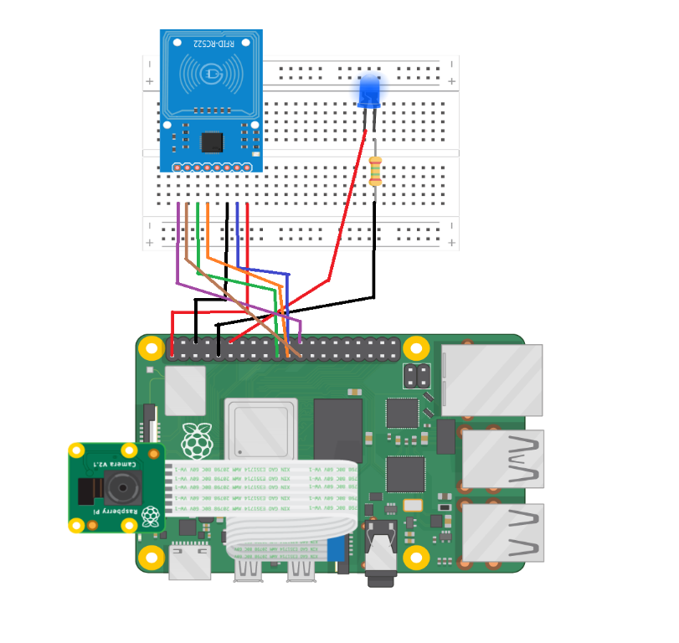

Figure 1 – Model

Pin out:

RFID pinout:

SDA to pin 24, SCK to pin 23, MOSI to pin 19, MISO to pin 21, GND to pin 6, RST to pin 22, 3.3v to pin 1.

LED pinout: positive to pin 12, negative to pin 9.

1. **Step – by – Step Procedure**
2. Step 1

Download raspberry pi OS, type sudo raspi-config enable SPI (for RFID) and legacy camera, then reboot

1. Step 2

Run the following commands:

sudo apt update

sudo apt upgrade

sudo apt-get install -y libhdf5-dev libhdf5-serial-dev python3-pyqt5 libatlas-base-dev libjasper-dev

sudo apt install python3-dev python3-pip

sudo pip3 install spidev

sudo pip3 install mfrc522

sudo pip3 install dlib

sudo pip3 install RPi.GPIO

sudo pip3 install opencv-python

1. Step 3

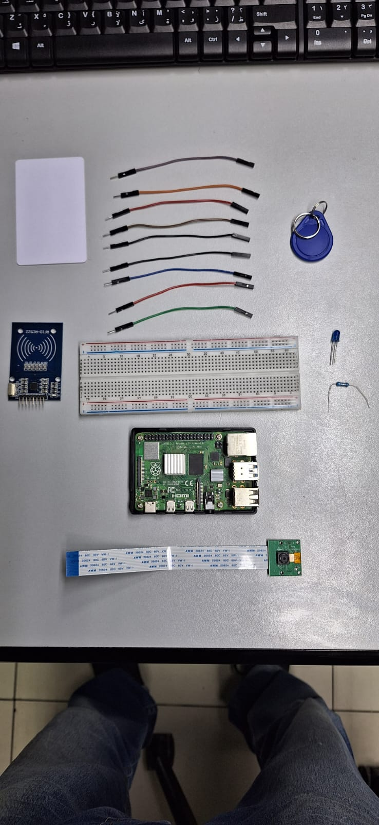

Figure 2 - Components

1. Step 4

Figure 3 - Wiring and Placing

1. Step 5

Figure 4 - Raspberry Pi 4 and Model 5 Camera

1. **Problems Faced and Solutions**  
    Problem implementing real-time facial recognition decided to use the camera to send the images to the RFID holder via email using SMTP.
2. **Results and Conclusions**
3. Results

The implementation of the IoT-based attendance tracking system using a Raspberry Pi 4, RFID technology, and email notifications has yielded promising results. Through rigorous testing and evaluation, the system has demonstrated its ability to automate the attendance verification process, capture facial images, and send instant email notifications.

During testing, the system accurately detected the presence of individuals when they tagged their RFID cards onto the sensor. The RFID technology provided a convenient and reliable method of identification, ensuring accurate attendance tracking. The integration of the Model 5 camera allowed for the capture of high-resolution facial images, further enhancing the system's accuracy, and providing visual evidence of attendance.

The email notification feature successfully generated automated emails upon successful attendance verification. These emails contained relevant details, such as the date, time, and location of the attendance record, ensuring timely communication and confirmation. The system also stored the attendance records in a CSV file, enabling efficient tracking and management of attendance data.

1. Conclusions  
   In conclusion, we successfully implemented a functioning attendance system that meets our expectation, given the limited hardware, it can also be built upon for future enhancements, the project is light weight and optimized enough so it can also be ported to the raspberry pi zero w.